**DONOR ME: MANAGE THE CONNECTION BETWEEN BLOOD BANK AND DONORS**

Project ID: 2022-311

B.N DULLEWA

(IT19112992)

B.Sc. (Hons) Degree in Information Technology Specializing in Information Technology

Department of Information Technology

Sri Lanka Institute of Information Technology Sri Lanka

September 2022

**DONOR ME: MANAGE THE CONNECTION BETWEEN BLOOD BANK AND DONORS**

B.N DULLEWA (IT19112992)

Supervised by: Ms. Uthpala Samarakoon

Final Project Thesis

Dissertation submitted in partial fulfilment of the requirements for the Bachelor of Science (Honours) Degree in Information Technology Specializing in Information Technology

Department of Information Technology

Sri Lanka Institute of Information Technology Sri Lanka

September 2022

# **Declaration**

To the best of my knowledge and belief, this dissertation does not contain any previously published or written by another person material, except where the acknowledgement is made in the text. I declare that this is my own work, and this dissertation does not incorporate without acknowledgement any material previously submitted for a degree or diploma in any other university or Institute of higher learning. Additionally, I hereby grant non-exclusive rights to Sri Lanka Institute of Information Technology to reproduce and disseminate my dissertation entirely or in part in print, electronic, or other formats. I reserve the right to include all or part of this content into my future works (such as article or books).

|  |  |  |
| --- | --- | --- |
| Name | Student Id | Signature |
| B.N Dullewa | IT19112992 |  |

The supervisor/s should certify the dissertation with the following declaration.

The above candidate has carried out research for the bachelor’s degree

Dissertation under my supervision.

______________________ 10/21/2022

Signature of the supervisor: Date:

# **Abstract**

The most precious gift that a human being could give to another is blood and the necessity for blood becomes very crucial when one begs for life from anaemia. In emergent circumstances, the number of victims is out of control and a victim may need more than 100 pints of blood. Patients need blood to survive operations, cancer treatments, chronic illnesses, and severe traumas. Blood is always necessary. Always it can help to save life. However, only approximately 3% of those who are old enough donate blood each year. A mobile application for managing blood camping is a huge blessing in today's challenging world, and the goal here is to find blood camp organizers to find proper location to hold blood donation camps. This paper primarily concerned with managing blood donation camp. This is called “DonorMe”, which allows people who want to donate blood to help others in need to do so. It enables people to get select the proper location to hold the blood donation camp In Sri Lanka, there is no technology to properly manage blood donation camps. This proposed product allows blood organizers to enter details, including name, date, time, and blood camp location using by google map. This mobile application enables donors to see the nearest blood donation camp through the system. Those who desire to donate blood can obtain information through this platform and they can navigate to the camp location using google map.

# **Acknowledgement**

I would like to express my gratitude to my supervisor, Mrs Uthpala Samarakoon and my co-supervisor Suriyaa Kumarie , who guided me through this project. As well as I am acknowledging to all my team members namely R.M.S Dananjani, K.U.R.O.D Bandara, Malkanthi P.L and all peoples who have helped me in order to get the research success.

Thank You

B.N Dullewa

IT19112992

**TABLE OF CONTENTS**

**Declaration** iii

**Abstract** iv

**Acknowledgement** v

**LIST OF FIGURES** vii

**LIST OF TABLES** vii

**1.** **Introduction** 1

**1.1 Background Literature** 4

**1.2 Research Gap** 6

**1.3 Research Problem** 8

**1.4** **Objectives** 10

**1.4.1 Specific Objectives**  10

**1.4.2 Specific Objectives**  10

**2.Methodology** 12

**2.1 Methodology** 12

**2.2 Testing and Implementation** 24

**2.3 Implementation** 26

**2.4 Commercialization** 27

**3.Results and discussion** 28

**3.1 Research Findings** 28

**4.Conclution** 29

**5.References** 30

**6.Appendices** 33

**6.1 Grant chart** 33

**6.2 Mobile application Manifest** 34

**6.3 Retrofit Instance Interface** 35

**6.4 Mobile application UI development** 36

# **LIST OF FIGURES**

Figure 1 Comparison of Annual Blood Collection 2

Figure 2 Comparison of Annual Blood Collection II 3

[Figure 3 Blood donors Count in Sri Lanka 8](https://mysliit.sharepoint.com/sites/CDAPSubmissionCloud/2022RegCloud/2022-311-Students/6.%20Final%20Report%20&%20Presentation/Final%20Reports/IT19112992_B.N%20Dullewa.docx#_Toc117266589)

[Figure 4 Whole blood donation per 1000 Population 8](https://mysliit.sharepoint.com/sites/CDAPSubmissionCloud/2022RegCloud/2022-311-Students/6.%20Final%20Report%20&%20Presentation/Final%20Reports/IT19112992_B.N%20Dullewa.docx#_Toc117266590)

[Figure 5 Software Life Cycle Model 12](https://mysliit.sharepoint.com/sites/CDAPSubmissionCloud/2022RegCloud/2022-311-Students/6.%20Final%20Report%20&%20Presentation/Final%20Reports/IT19112992_B.N%20Dullewa.docx#_Toc117266591)

Figure 6 System Overview 13

[Figure 7 System Flow Chart 14](https://mysliit.sharepoint.com/sites/CDAPSubmissionCloud/2022RegCloud/2022-311-Students/6.%20Final%20Report%20&%20Presentation/Final%20Reports/IT19112992_B.N%20Dullewa.docx#_Toc117266593)

Figure 8 System Breakdown Structure 15

[Figure 9 Use case diagram 16](https://mysliit.sharepoint.com/sites/CDAPSubmissionCloud/2022RegCloud/2022-311-Students/6.%20Final%20Report%20&%20Presentation/Final%20Reports/IT19112992_B.N%20Dullewa.docx#_Toc117266595)

[Figure 10 Used Algorithms 17](https://mysliit.sharepoint.com/sites/CDAPSubmissionCloud/2022RegCloud/2022-311-Students/6.%20Final%20Report%20&%20Presentation/Final%20Reports/IT19112992_B.N%20Dullewa.docx#_Toc117266596)

[Figure 11 Firebase Authentication 19](https://mysliit.sharepoint.com/sites/CDAPSubmissionCloud/2022RegCloud/2022-311-Students/6.%20Final%20Report%20&%20Presentation/Final%20Reports/IT19112992_B.N%20Dullewa.docx#_Toc117266597)

[Figure 12 Splash Screen of the Application 20](https://mysliit.sharepoint.com/sites/CDAPSubmissionCloud/2022RegCloud/2022-311-Students/6.%20Final%20Report%20&%20Presentation/Final%20Reports/IT19112992_B.N%20Dullewa.docx#_Toc117266598)

[Figure 13 First Look of the Application 20](https://mysliit.sharepoint.com/sites/CDAPSubmissionCloud/2022RegCloud/2022-311-Students/6.%20Final%20Report%20&%20Presentation/Final%20Reports/IT19112992_B.N%20Dullewa.docx#_Toc117266599)

[Figure 14 Predict functionality screen of the Application 20](https://mysliit.sharepoint.com/sites/CDAPSubmissionCloud/2022RegCloud/2022-311-Students/6.%20Final%20Report%20&%20Presentation/Final%20Reports/IT19112992_B.N%20Dullewa.docx#_Toc117266600)

[Figure 15 Organizer Screen III 21](https://mysliit.sharepoint.com/sites/CDAPSubmissionCloud/2022RegCloud/2022-311-Students/6.%20Final%20Report%20&%20Presentation/Final%20Reports/IT19112992_B.N%20Dullewa.docx#_Toc117266601)

[Figure 16 Organizer Screen II 21](https://mysliit.sharepoint.com/sites/CDAPSubmissionCloud/2022RegCloud/2022-311-Students/6.%20Final%20Report%20&%20Presentation/Final%20Reports/IT19112992_B.N%20Dullewa.docx#_Toc117266602)

[Figure 17 Organizer Screen I 21](https://mysliit.sharepoint.com/sites/CDAPSubmissionCloud/2022RegCloud/2022-311-Students/6.%20Final%20Report%20&%20Presentation/Final%20Reports/IT19112992_B.N%20Dullewa.docx#_Toc117266603)

Figure 18 Tools and Techniques 26

[Figure 19 Grant Chart 33](https://mysliit.sharepoint.com/sites/CDAPSubmissionCloud/2022RegCloud/2022-311-Students/6.%20Final%20Report%20&%20Presentation/Final%20Reports/IT19112992_B.N%20Dullewa.docx#_Toc117266605)

[Figure 20 Mobile Application Manifest 34](https://mysliit.sharepoint.com/sites/CDAPSubmissionCloud/2022RegCloud/2022-311-Students/6.%20Final%20Report%20&%20Presentation/Final%20Reports/IT19112992_B.N%20Dullewa.docx#_Toc117266606)

Figure 21 Retrofit Instance Interface 35

[Figure 22 UI development 36](https://mysliit.sharepoint.com/sites/CDAPSubmissionCloud/2022RegCloud/2022-311-Students/6.%20Final%20Report%20&%20Presentation/Final%20Reports/IT19112992_B.N%20Dullewa.docx#_Toc117266608)

Figure 23 XML file of the mobile Application 37

[Figure 24 Firebase Realtime Database 38](https://mysliit.sharepoint.com/sites/CDAPSubmissionCloud/2022RegCloud/2022-311-Students/6.%20Final%20Report%20&%20Presentation/Final%20Reports/IT19112992_B.N%20Dullewa.docx#_Toc117266610)

[Figure 25 Turnitin 39](https://mysliit.sharepoint.com/sites/CDAPSubmissionCloud/2022RegCloud/2022-311-Students/6.%20Final%20Report%20&%20Presentation/Final%20Reports/IT19112992_B.N%20Dullewa.docx#_Toc117266611)

[Figure 26 Emergency Blood donation 40](https://mysliit.sharepoint.com/sites/CDAPSubmissionCloud/2022RegCloud/2022-311-Students/6.%20Final%20Report%20&%20Presentation/Final%20Reports/IT19112992_B.N%20Dullewa.docx#_Toc117266612)

[Figure 27 Organ Donation 41](https://mysliit.sharepoint.com/sites/CDAPSubmissionCloud/2022RegCloud/2022-311-Students/6.%20Final%20Report%20&%20Presentation/Final%20Reports/IT19112992_B.N%20Dullewa.docx#_Toc117266613)

[Figure 28 Predict Blood for future usage 42](https://mysliit.sharepoint.com/sites/CDAPSubmissionCloud/2022RegCloud/2022-311-Students/6.%20Final%20Report%20&%20Presentation/Final%20Reports/IT19112992_B.N%20Dullewa.docx#_Toc117266614)

# **LIST OF TABLES**

*Table 1 Research Gap with Research Papers 7*

*Table 2 Test Cases 25*

*Table 3 Camp managing fee 27*

*Table 4 Advertising fee 27*

# **Introduction**

Blood is necessary for people to recover after operations, cancer treatments, long-term illnesses, and severe injuries. The donation of blood saves lives in an emergency and helps those who require long-term therapies. If blood donors had not kindly given their blood, many people might not be living today. Blood donation is the act of giving blood to someone who requires a transplant. A person's life may be saved or entirely changed through a transplant. More than ten people's lives can be saved by a single blood donor. Scientists calculate that a person's blood volume makes up about 7% of their body weight. Blood volume in an average adult body weighing 150 to 180 pounds ranges from 4.7 to 5.5 liters (1.2 to 1.5 gallons). [1]. According to American red cross, person who desire to donate blood need to have following requirements. They are, must be in good health and feeling well, must be at least 18 years old in most states and must weigh at least 110 lbs.

Today in modern world, most of the blood donors are unpaid volunteers who donated blood as their responsibility. Many people give blood for a variety of reasons, including altruism, knowledge of the need for blood in general, boosted self-esteem, aiding a friend or relative personally, and societal pressure. Even though there are numerous benefits to giving, not enough potential donors actively donate.

In the medical sector, blood is donated in the conventional way through blood donation services or blood banks all around the world. A blood bank is a facility where blood is processed and maintained for a maximum of four weeks prior to transfusion as a consequence of donor blood donation campaigns. In Sri Lanka, Blood donors do not have a system to connect with blood donation camps and the organizers do not have a system to connect with the donors. Also, organizers do not have a system to manage their blood donation camps successfully. This application is developed for smart phones. The Intelligent Blood Donation System mainly provides solutions for these major issues. The main duty of this function is to find proper location to hold blood donation camp.

The system aids to locate the potential donors from the respective areas of emergency. A notification will be sent to the potential donors from the nearby areas of emergency. It simplifies the process of reaching out to potential donors and encourages them to become voluntary donors. Donors can also track the nearest blood donation camp details. Moreover, The system helps proper management of blood donation camps. If an organizer needs to organize blood donation camp within 40km using google map, then she/he can create a camp choosing proper location. The system shows previous blood camp locations using that organizer can decide a suitable place. The potential donors will be notified through an auto generated message when new blood camp is organized. The blood donors can detect the nearest available blood donation camps withing 40km.

The annual units of blood collections in Sri Lanka are roughly depicted in the figures below [2]. This emphasizes the importance of the voluntary Blood Donor Service as a primary source of blood in Sri Lanka. According to that information, 2019 shows a decrease in blood donation. This may be due to the covid pandemic situation. It is important to create a system to make it easier for donors across the island to donate blood. It will make it easier for donors as well as blood camp organizers. This project tries to answer this critical issue of an efficient and effective blood donation camp management system. Main features are the donor can check nearest blood camp, organizers can find a place to hold their blood donation camps and it will provide information about the camps previously conducted in selected area.

**Comparison of Annual Blood Collection**

Figure 1 Comparison of Annual Blood Collection

Figure 2 Comparison of Annual Blood Collection II

## **1.1 Background Literature**

(K M Akkas Ali1, Israt Jahan, Md. Ariful Islam, Md. Shafa-at Parvez, Year - 2015) developed a Blood Donation Management Application. This application mainly developed using donor details. When donor login to the system, donor need to enter basic information such as their donor name, donor’s blood type, donor’s email address, password, and precise location. From that system visitors can filter blood donor by their blood group. It does not include blood camp functionality.

(T.Hilda Jenipha R.Backiyalakshmi, Year - 2014) developed a Blood Donor Application that displays all of the active donors in relevant areas. User is able to locate matching blood groups in same area. However it does not include blood camp managing function or any other function related to blood camping.

(Prof. Snigdha1, Varsha Anabhavane, Pratiksha lokhande3, Siddhi Kasar4, Pranita, Year -2016) has implemented a mobile application that includes all donor’s details in respective area. It is like directory of local blood donors. Entering donor’s personal details such as name, age , phone number, address and blood type he/she can login to the system as a donor. If any emergency donees can find out a donor according to their requirement. This app had used Global positioning System technology to trach the blood bank rout. This application also not implemented any blood donation camping features.

(Moh. Nabil a, R. Ihab b, H. El Masr c, S. Said d, S. Youssef e, Year - 2019) had developed a Cloud medical monitoring and Web-Based Blood Donation System and it is allowing the donors and donees to request blood donation to blood bank. If the donee needs any type of blood he/she can asked to donate blood to the relevant person. This system also not implements any functionality related to the blood donation camping.

Various researches have been done on the design and development of blood donation application and research on the views and concerns of the general public regarding such mobile applications. above research has shown that Find donors (Applications that assist users in finding donors), some researches records donors details and able to filter donors according to their living location, Blood types [3](Applications that provide information on a user's blood kinds), BD eligibility (Apps which calculate the date on which the user may donate blood based on the date of her / his last) BD General(Apps which provide general information about applications such as the BD process) are currently being developed (Sofia ohubi et al , Year - 2015) [4].

## **1.2 Research Gap**

In Sri Lanka, a large number of individuals are deferred from donating blood each year. Deferrals might be detrimental to donors' satisfaction and subsequent word-of-mouth advertising. This is why it is important to create the unique platform for those who desire to donate blood. According to the research papers mentioned above, there is not fully functional application for blood donation sector including blood donor and donee communication management, managing blood donor details, managing organ donation and blood donation camping management. Several studies were found from blood donors who were close to where the blood was needed, including GPS mapping of the area. It seems like there are not fulling functioning system for managing blood donation camp. If organizers can notify donors through autogenerated message or donors can see the upcoming donation camps in nearest area, it will be easy for both donors and organizers. Also, once a person has donated blood, he or she will not be able to donate blood again until 4 months later. There are no research which provide donors with any sort of online passbook.

To our knowledge, only a few studies have focused on managing blood donation camp within the blood donation context. Any of these researchers did not implement about this functionality. All the main functionalities have mentioned in the table as below. Only the research of (Prof. Snigdha1, Varsha Anabhavane, Pratiksha lokhande3, Siddhi Kasar4, Pranita, Year - 2016) had developed system with location functionality but it is not for blood donation camps. it is for blood banks. other three researches had implemented systems like donors logbook.

Table 1 Research Gap with Research Papers

|  |  |  |  |  |
| --- | --- | --- | --- | --- |
| Research | Selecting proper location to hold blood donation camp | Suggests proper date | Locate to nearest blood donation camp | Provide location details about previous camps to the organizer |
| (K M Akkas Ali1, Israt Jahan, Md. Ariful Islam, Md. Shafa-at Parvez, Year - 2015) | No | No | No | No |
| (T.Hilda Jenipha R.Backiyalakshmi, Year - 2014) | No | No | No | No |
| (Prof. Snigdha1, Varsha Anabhavane, Pratiksha lokhande3, Siddhi Kasar4, Pranita, Year - 2016) | No | No | Yes | No |
| (Moh. Nabil a, R. Ihab b, H. El Masr c, S. Said d, S. Youssef e, Year -2019) | No | No | No | No |

## **1.3 Research Problem**

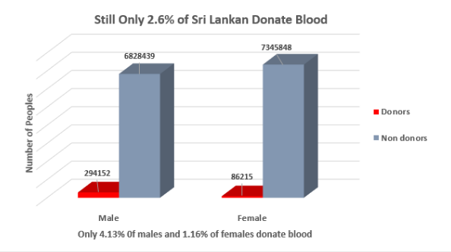There has been a significant increase in deaths Due to a lack of quick blood donors and the bureaucracy associated with sick people quickly receiving their required blood type. Donation rates are less than 1% in 73 nations (fewer than 10 donations per 1000 people). 70 of these are transitional or developing countries [5]. It shows the importance of donating blood. According to the following graph , there are not a significant number of people willing to donate blood.

Figure 3 Blood donors Count in Sri Lanka

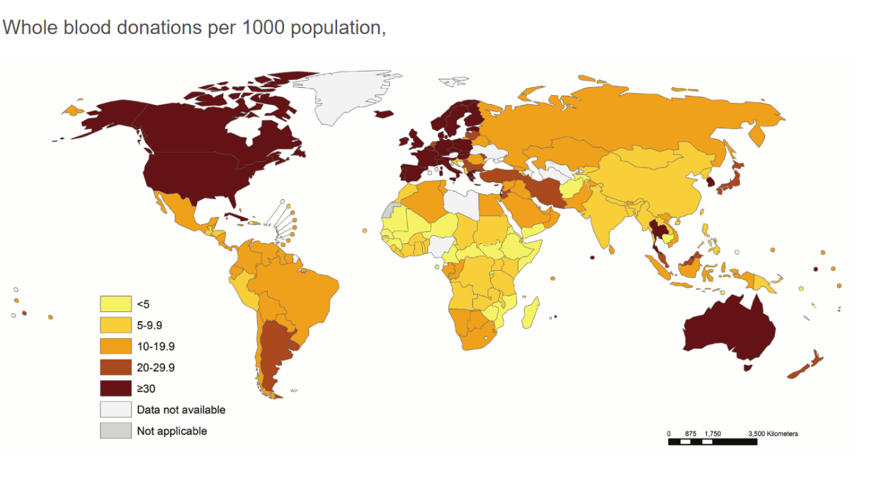According to the following world report out country is not in a significant state [6].

Figure 4 Whole blood donation per 1000 Population

Organizing blood camps can solve this problem. But there is no correct guidance for organizers. Moreover, when donor needs to donate their blood, she/he has to go to the blood bank. It takes time and effort. If it is possible to raise awareness about the nearest camps, it will solve these problems. If the organizers want to hold a successful camp, they have to be careful about the location they choose. Currently there is no system that has been created to conduct organizers. But having a system can be good guidance to the organizers.

It is simple to distribute information about blood donations due to the significant development in the use of social networking sites around the world. However, as evidenced by the number of posts on sites like Facebook and Twitter requesting blood donors, the number of calls for blood donors has been steadily increasing as a result of the use of contemporary technologies. It is difficult to discover the regions where blood donation camps are held and to effectively notify potential donors due to a lack of contact with social networking sites. As a solution, this program uses technology to help discover contributors.

## **Objectives**

### **1.4.1 Specific Objectives**

Design and develop a component to manage the blood donation camps effectively using Google API and social media.

### **1.4.2 Specific Objectives**

In order to manage blood donation campaigns dynamically, this study proposes an integrated blood donation camp management system that is a web-based application with mobile compatibility. In Sri Lanka, there is no technology to properly manage blood donation camps. A person who wants to arrange a blood donation camp might use this app to find a location with possible donors. Those who desire to donate blood can obtain information about the nearest blood donation camp. Use a dashboard to keep track of the blood percentages based on data from a blood donation camp.

This function includes blood donation event handling. Use a dashboard to keep track of the blood percentages based on data from a blood donation camp. We do not use the client’s name and instead, we give them a unique ID where the clients could be recognized, and the details could be managed through the ID.

* Select the proper location to hold the blood donation camp.
* If a person needs to organize a blood donation event, the person can easily find a proper area.
* The current availability of registered blood donators detected in the respective blood donation camp’s area
* The event organizer can find how many blood donators are detected in the event area by selecting the area name.
* The potential donors will be notified through an auto-generated message.
* When a person organizes a new blood donating event, registered users will be notified through a message.
* Locate the nearest blood donation camp and the camps which are to be held in the future.
* If a person needs to donate blood, the donor can locate the nearest available blood donation camp and the path via the map.

# **2.Methodology**

### **2.1 Methodology**

This mobile-based blood bank management system provides offer several, including publicizing blood donation event to the general public and enabling the general public to both request and donate blood. All donors, recipients, and blood donation programs are recorded in the system. This system can also keep track of the donors' donation and blood camp histories as well as the blood bank's blood supply. The advantage of application any person who is interested in donating blood can register himself as a donor. System track blood camp locations and relevant user navigates to the location. Furthermore, if any general consumer needs guidance for organizing blood camp she/he can get guidance from this application. This function also focused on user interactions and user behaviors, so it is considered about HCI aspects.

For the deployment, we're using the Flask API. All validation techniques are written and implemented using retrofit APIs and coroutines. The framework selected for the development is Flutter for designing a user-friendly web application. The mobile application is directly connected to the Firebase real-time database. Firebase helps to store data within mobile application. The following diagram illustrates the main components of the project. GitHub, GitLab and Android studio as the development tool and project management tool and followed SDLC for development.

Figure 5 Software Life Cycle Model

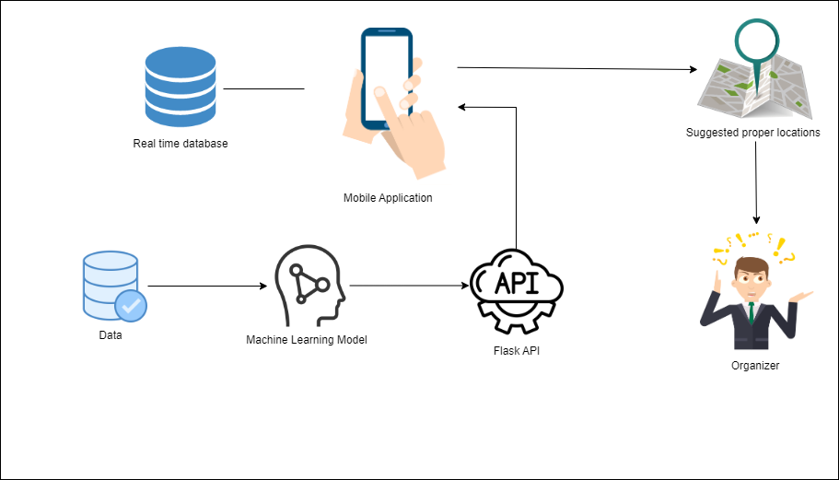

Figure 6 System Overview

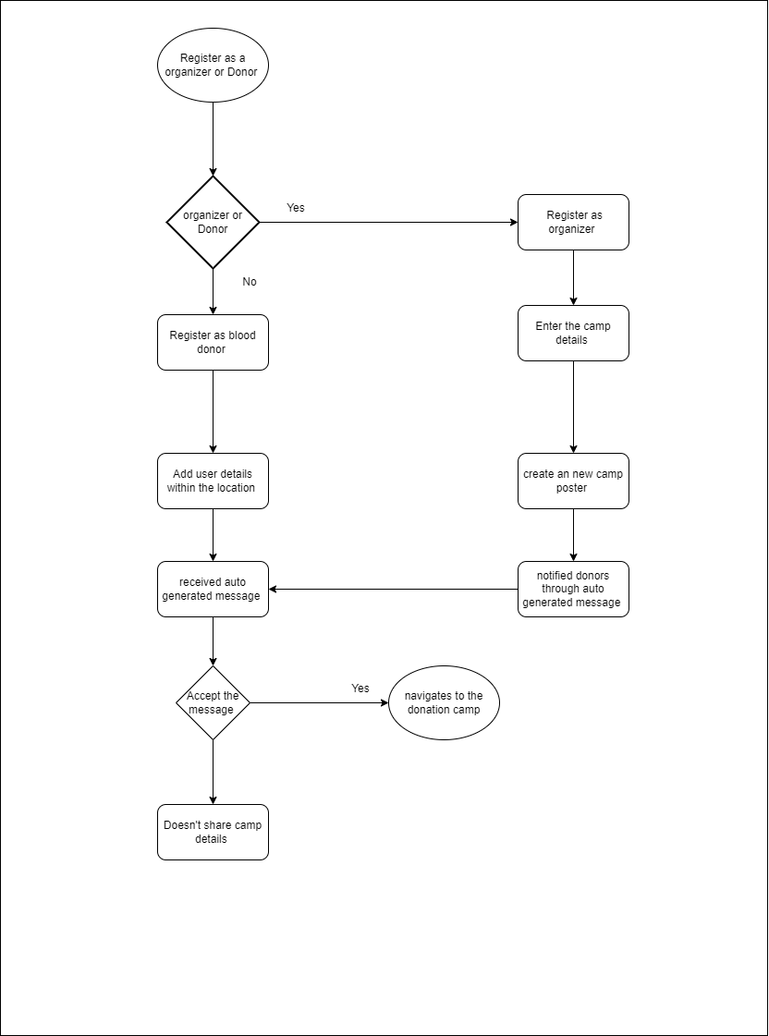System Flow chart

Figure 7 System Flow Chart

System Breakdown Structure

Figure 8 System Breakdown Structure

Use case diagram

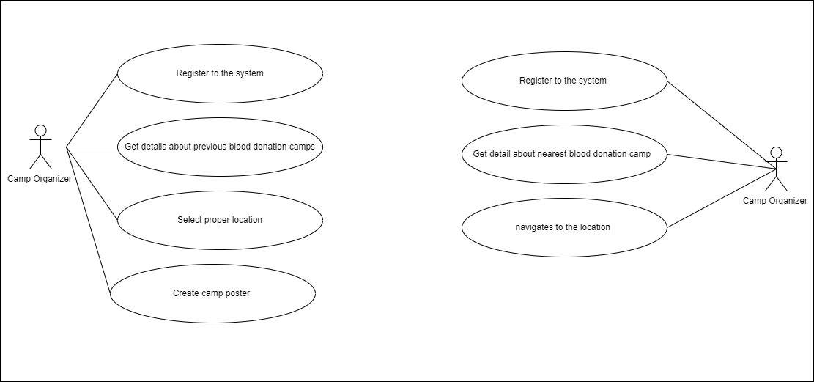

Figure 9 Use case diagram

All the users within 40km can see blood donation camp details. Flowing image is showing that algorithm we have user for that.

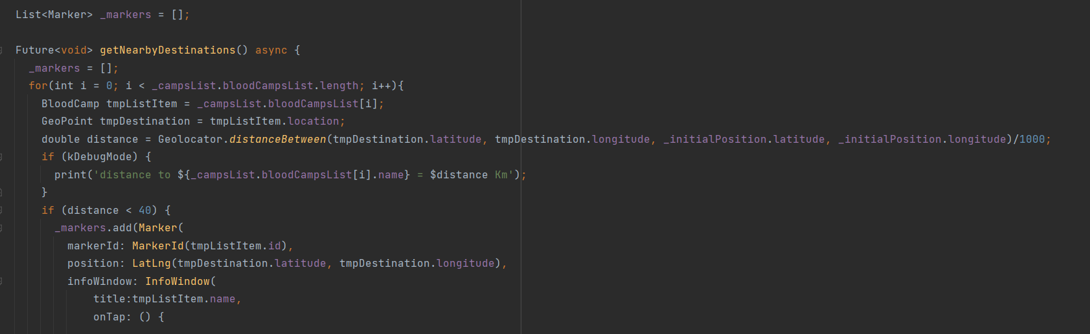

Figure 10 Used Algorithms

#### **2.1.1 Automated Recommendation System**

API Implementation

We need to create a REST API that can interact with any service in order to take advantage of these models. For this, the flask framework has utilized . It is scalable to sophisticated applications. And then integrated the flask endpoint with the mobile application and implemented flask to the algorithms as methods. The API is called every time the JSON file is generated. The retrofit API and coroutines are used to script each validation algorithm. Buttons, text views, and text boxes on user interfaces are allocated and verified using API calls.

Database Handling

Firebase

A database is required by this system for validation purposes. It is required to identify specific users in order to develop a recommendation system based on users. For user authentication, used firebase authentication. Scripts that manage Firebase authentication, storage, and real-time data base validations communicate the user's pertinent information to the Flask server when the user logs into the system.

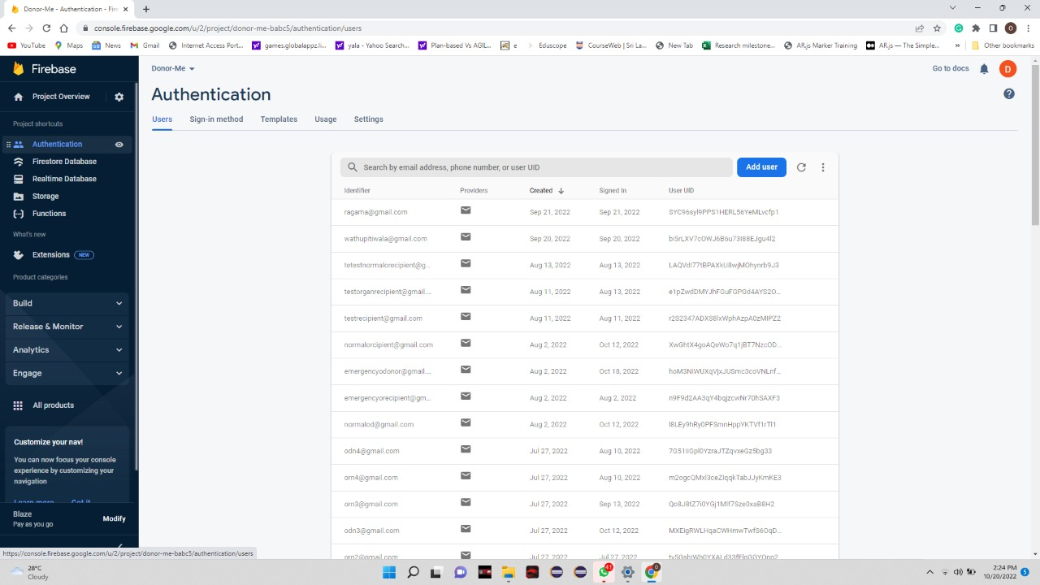

Figure 11 Firebase Authentication

Proposed system

As a medical sector application, the proposed system’s interfaces designed after considering that. It built and configured to allow communication between the hospital, blood donors blood donees, organ donor and donees and camp organizers. In times of need, we employ geolocation and geotagging to locate contributors utilizing a range of location-specific data and to pinpoint the donors' exact whereabouts.

When a user first opens the Mobile Application, the splash page displayed as shown in following image snd we named our mobile application as “**DonorMe**”.

Figure 12 Splash Screen of the Application

Figure 13 First Look of the Application

Figure 14 Predict functionality screen of the Application

We have chosen red color as our thema color and chosen suitable wallpapers and suitable worlds for medical application

Following images will shows organizer dashboard and poster creating form and suggested dates are highlighted in yellow color.

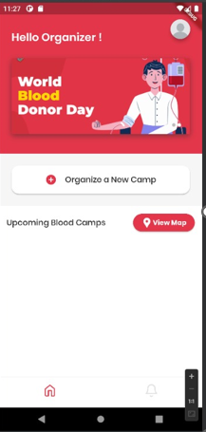

Figure 15 Organizer Screen III

Figure 16 Organizer Screen II

Figure 17 Organizer Screen I

#### **2.1.2 Software Development Process**

During this phase, analysing the collected requirement and gathering more information. Converting the requirement to an actual product should be the final output of this cycle.

**Planning -** The entire scope of project and product management is covered at the planning phase. This often comprises allocating resources, planning for capacity, scheduling projects, estimating costs, and making provisions**.** Planned evaluation date and released data also decided in this phase. There are three main parts in this phase. They are ,

Coding phase – taking decisions for development environment, tools and techniques are includes for this phase. Reviewing coding and final product with multiple devices also includes. Flutter, Android studio, Firebase, Figma planned to select for this product.

Building Phase - Using the previously established code requirements to develop the software is the first stage in the building process.

Testing Phase - This stage comprises evaluating the created program. The testing team evaluates the generated product to see if it complies with the standards outlined in the "planning" phase.

Deploy Phase – In this phase, the program is officially released into production setting

**Analysis -** Analysis requirements is considered to be a component of planning because it identifies the goals and requirements of the application.

**Designing -** The design stage creates a working model of the software program. First, we design outline the details for overall application. Creating wireframes, creating UI is doing this phase. A step in the design process that includes prototyping. In the iterative software development approach, a prototype is comparable to one of the early software versions.

**Implementation -** The software we have designed come together. Members commonly used training environments to discover additional issues or defects when working to integrate multiple modules or designs into the main source code. After passing this step, the application can possibly be made available to any end users.

**Testing –** This project currently passing this stage. We have created test cases. We have done UI testing , performance testing , functional and end to end testing

**Maintenance -** The SDLC doesn't end when software is put up for sale. It is now necessary for developers to switch into maintenance mode and begin carrying out any operations required to fix issues raised by end users.

#### **2.1.2 Software Specific Requirement**

Functional Requirements

* Login​
* Registration​
* send auto-generated message to register users​
* Locate nearest blood donation camp
* Suggest proper location to the organizer
* Suggest proper date to the organizer

Non-Functional Requirements

* Availability
* Security and privacy
* Performance
* Usability

 Software Requirements

* Install the application

Hardware Requirements

* Android device

### **2.2 Testing and Implementation**

#### **2.2.1. Testing**

In this phase we done integration and testing. We have divided testing in to two parts as automation testing and manual testing. For Manual testing we have wrote test cases in TestLink as follows.

|  |  |  |
| --- | --- | --- |
| Test cases | Status | QA Comment |
| Verify UI elements of Organizer dashboard | Failed | Spellings mistake in 'Continue' button |
| Verify UI elements of create camp Form | Passed |  |
| Verify functionality of 'Organize a new camp' button | Passed |  |
| Verify functionality of 'View Map' button | Passed |  |
| Verify functionality of 'Continue' button | Passed |  |
| Verify functionality of 'Login' button | Passed |  |
| Verify functionality of 'Ok' button | Passed |  |
| Verify user is able to login as an organizer | Passed |  |
| Verify user is able to navigate new donation camp screen | Passed |  |
| Verify 'Select Data' text field | Passed |  |
| Verify 'Mobile Number' text field | Passed |  |
| Verify 'Organizer Name' text field | Passed |  |
| Verify user can create new Blood donation camp poster with valid date | Passed |  |
| Verify user can create new Blood donation camp poster with invalid date | Passed |  |
| Verify user can create new Blood donation camp poster with mandatory fields | Passed |  |
| Verify user can create new Blood donation camp poster without mandatory fields | Passed |  |
| Verify user can create new Blood donation camp poster with invalid fields | Passed |  |
| Verify user can create new Blood donation camp poster without selecting location | Passed |  |
| Verify donor can see blood donation camp poster | Passed |  |
| Verify donor can see blood donation camp location | Passed |  |
| Verify donor can see camp poster with correct details | Passed |  |
| Verify user can navigate to the correct location | Passed |  |
| Verify camp poster | Passed |  |
| Verify Admin can see camp request | Passed |  |
| Verify Admin can accept camp request | Passed |  |
| Verify Admin can reject camp request | Passed |  |
| Verify donor can only see Admin Accepted posters | Passed |  |
| Verify donor is unable to see Admin rejected posters | Passed |  |
| Verify latest camp request is in top of the queue in admin screen | Passed |  |

*Table 2 Test Cases*

### **2.3 Implementation**

This step explains how the system that was designed is put into use. At this point, the suggested system is being developed using multiple technologies, tools, and software. This phase will see the implementation of every system we have created. Each team member is required to design four unique modules using a variety of tools and technologies.

Tools and techniques –

Figure 18 Tools and Techniques

### **2.4 Commercialization**

After the covid 19, this kind of applications get great demand. But we have implemented this as volunteering application because of that we hope to give this application as a free application for government hospital sectors. To maintain this application, we hope to give this application to private hospitals as a paid application. Private hospital can publish their advertisements. And also organizers can post their first five blood camp posters for free and if the limit is exceed then they need to purchase the application as donor.

**Camp Managing**

|  |  |  |
| --- | --- | --- |
| **Component** | **USD** | **LKR** |
| **Create Posters > 10** | 3.25 Per Year | 1179 Per Year |
| **Create Unlimited Posters** | 20 Per Year | 8000 Per Year |

*Table 3 Camp managing fee*

**Advertisement**

|  |  |  |
| --- | --- | --- |
| **Component** | **USD** | **LKR** |
| **Government** | free | free |
| **Private** | 20 Per Year | 10000 Per Year |

*Table 4 Advertising fee*

# **3.Results and discussion**

## **3.1 Research Findings**

The system was tested using ten test devices. After examining how each user's activity affected the recommendation system, both previously registered users and new users were successfully used to test the system's fundamental functions.

The mobile application is successfully built using the system we suggested, and as a team, we were successful in doing so. With the back end and the real-time databases integrated, all components function flawlessly. When a user logs in, the system will recognize their previous preferences. Additionally, the flask server allows the UI to receive output. And when another user logs in, the system is intelligent enough to specifically identify the user and give the relevant recommendations, and the system is aware that the user is satisfied with the recommendations. Additionally, the user can view animated, user-friendly graphs and plots that show demand forecasting and future demand prediction. When a new user logs in, the system will also identify the new user's behaviour and give the relevant recommendations in real-time.

# **4.Conclution**

In this study, we present a reinforcement learning-based recommendation task-performing system. Utilizing the increased processing power provided by technology breakthroughs, several organizations have reaped significant benefits. Numerous systems can be employed to address a variety of problems.

These 4 areas are integrated, and this application will be a perfect solution for people who desire to donate blood and hope to organize blood donation camp. As a free application for the donors it would be brilliant opportunity for the people who like to work as volunteers. Getting information from government hospital is not easy. Time is the most important aspect in our day to day life, when we are developing the system, we gave priority to time management as well, if we can save the time of the users, by giving smart intelligent service. I think that will be one of our top achievements. Nowadays, pre-programmed or hardcoded recommendations are inappropriate because there are an infinite number of potential outcomes due to the advancement of technology.

Finally, we can state that this system is capable of delivering the highest quality

# **5.References**

|  |  |
| --- | --- |
| [1] | WONDEROPOLIS, “How Much Blood Is In Your Body?,” [Online]. Available: https://wonderopolis.org/wonder/how-much-blood-is-in-your-body#:~:text=Scientists%20estimate%20the%20volume%20of,to%201.5%20gallons)%20of%20blood.. |
| [2] | N. B. T. Service, “Annual Report,” 2019. |
| [3] | J. L. F.-A. A. T. A. I. &. J. R. P. Sofia Ouhbi, “Free Blood Donation Mobile Applications,” 03 March 2015. |
| [4] | E. E. M. B. a. D. G. KCM de Alwis#, “A Mobile Application for Blood Transfusion in Sri Lanka for Emergency Cases Based on Government Hospitals,” Department of Information Technology, Faculty of Computing, General Sir John Kotelawala Defence . |
| [5] | W. H. Organization, “Blood safety and donation,” [Online]. Available: https://www.who.int/bloodsafety/global_database/GDBSFactSheet%20.pdf. |
| [6] | L. a. B. I. (. the National Heart. [Online]. Available: https://bloodsafe-research.org/. |
| [7] | E. V. P. A. Posey, “blood works,” [Online]. Available: https://www.bloodworksnw.org/donate/research#:~:text=When%20you%20donate%20blood%20for,for%20their%20ongoing%20medical%20research.. |
| [8] | A. C.-S. S. o. B. D. P. Characteristics, 2021 . [Online]. Available: https://www.karger.com/Article/FullText/517566. |
| [9] | T. A. D. A. ,. G. S. ,. G. Y. A. S. Dejene M, “Low Blood Donation Practice of Health Sciences College Students in Northeast Ethiopia: A Cross-Sectional Study,” 18 October 2020. [Online]. Available: https://www.dovepress.com/low-blood-donation-practice-of-health-sciences-college-students-in-nor-peer-reviewed-fulltext-article-JBM. |
| [10] | Vitalant, “Blood Donations For Research,” 2022. [Online]. Available: https://research.vitalant.org/Cell-Sourcing/Blood-Donations-For-Research.aspx. |
| [11] | 7. A. K. B. T. *. Abhishek Chaturvedi1, “A STUDY TO ASSESS THE BARRIERS AND FACILITATORS OF A STUDY TO ASSESS THE BARRIERS AND FACILITATORS OF INDIA,” 2022. |
| [12] | N. Y. B. Center, “Use of Donor Information and Blood Samples in Research,” 1 DECEMBER 2020. [Online]. Available: https://www.nybc.org/donate-blood/become-donor/donation-faqs/use-donor-information-blood-samples-in-research/. |
| [13] | B. D. P. a. A. F. i. E. A. S. R. a. Meta-analysis, “Blood Donation Practice and Associated Factors in Ethiopia: A Systematic Review and Meta-analysis,” [Online]. Available: https://www.hindawi.com/journals/bmri/2020/8852342/. |
| [14] | R. M. Winslow, “Current status of blood substitute research: towards a new paradigm,” 17 April 2003. [Online]. Available: https://onlinelibrary.wiley.com/doi/full/10.1046/j.1365-2796.2003.01150.x. |
| [15] | B. M. M. K. J.Terry, “The Psychology of Blood Donation: Current Research and Future Directions,” [Online]. Available: https://www.sciencedirect.com/science/article/abs/pii/S0887796308000151. |
| [16] | “Blood-on-a-Chip,” [Online]. Available: https://www.annualreviews.org/doi/abs/10.1146/annurev.bioeng.7.011205.135108. |
| [17] | J. D. R. J. T. L. J. M. L.M.Ferrara8GérardSocié, “Recommended Screening and Preventive Practices for Long-term Survivors after Hematopoietic Cell Transplantation: Joint Recommendations of the European Group for Blood and Marrow Transplantation, the Center for International Blood and Marrow Transplant Res,” 2 February 2006. [Online]. Available: https://www.sciencedirect.com/science/article/pii/S1083879105006762. |
| [18] | W. C. S. P. C. M. E.L. Wallace, “Collection and transfusion of blood and blood components in the United States,” 27 February 2003. [Online]. Available: https://onlinelibrary.wiley.com/doi/abs/10.1046/j.1537-2995.1998.38798346630.x. |
| [19] | B. Research. [Online]. Available: https://www.bloodresearch.or.kr/main.html. |
| [20] | H. E. Research, “Donating blood and organs: using an extended theory of planned behavior perspective to identify similarities and differences in individual motivations to donate,” 6 December 2013. [Online]. Available: https://academic.oup.com/her/article/28/6/1092/595647. |
| [21] | “What blood and organ donation can tell us about cooperation?,” 09 2021.. [Online]. Available: https://www.sciencedirect.com/science/article/pii/S2352250X21001743. |
| [22] | C. M. 2. R. E. O. 2. Eamonn Ferguson 1, “Blood and organ donation: health impact, prevalence, correlates, and interventions,” [Online]. Available: https://pubmed.ncbi.nlm.nih.gov/31213077/. |
| [23] | “Canadian Blood Service,” 2022. [Online]. Available: https://www.blood.ca/en/organs-tissues. |

# **6.Appendices**

## **6.1 Grant chart**

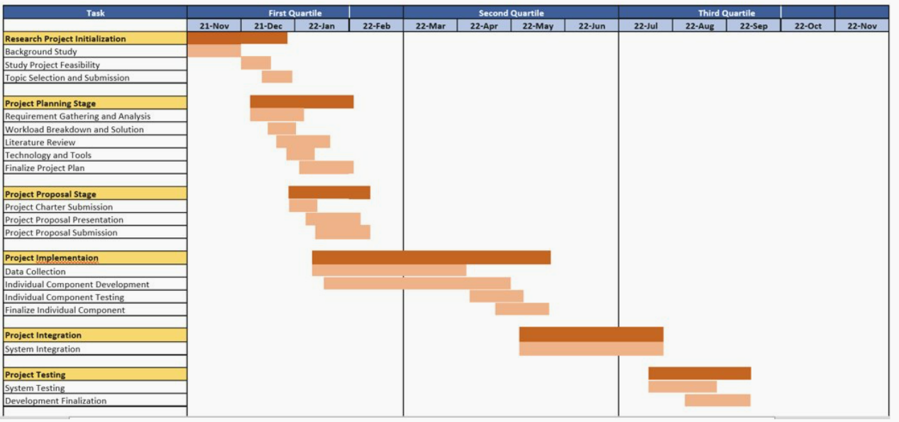

Figure 19 Grant Chart

## **6.2 Mobile application Manifest**

Figure 20 Mobile Application Manifest

## **6.3 Retrofit Instance Interface**

Figure 21 Retrofit Instance Interface

## **6.4 Mobile application UI development**

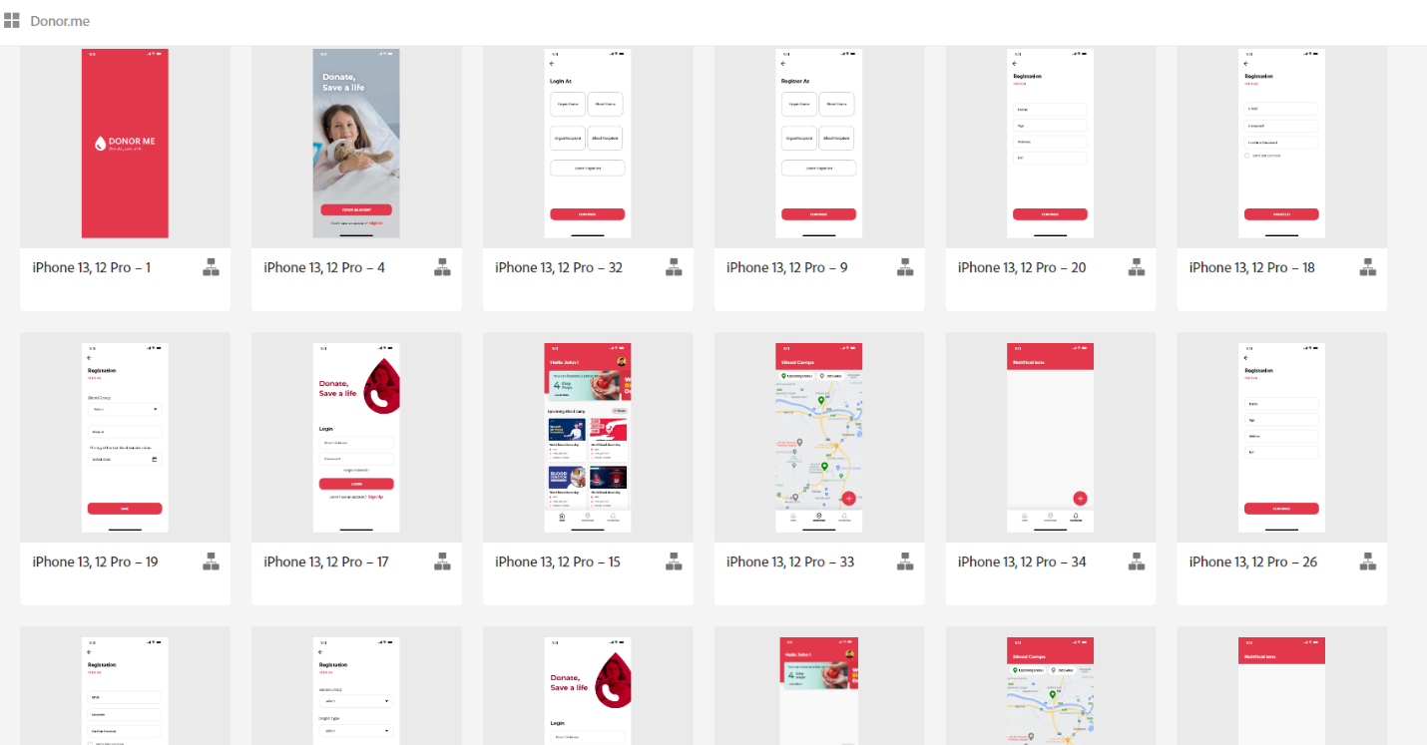

Figure 22 UI development

**6.5 Mobile application xml**

Figure 23 XML file of the mobile Application

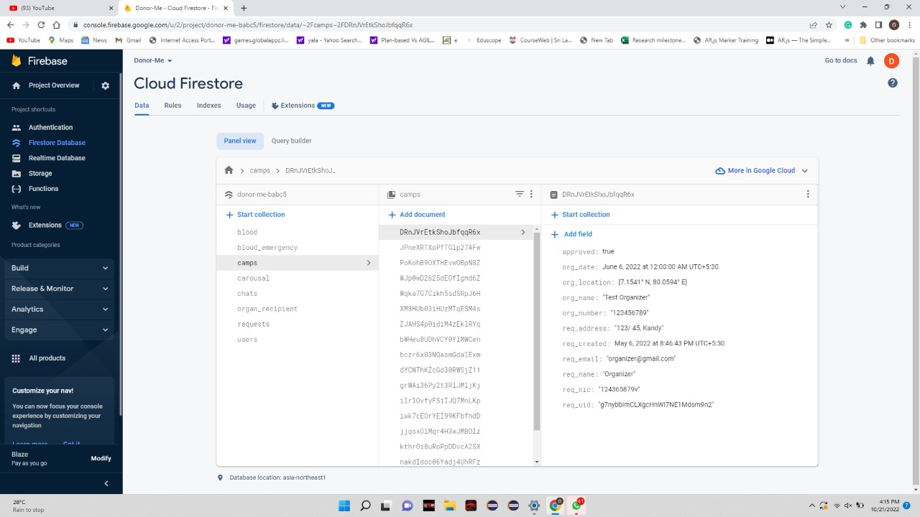**6.6 Firebase Realtime Database**

Figure 24 Firebase Realtime Database

**6.7 Turnitin**

Figure 25 Turnitin

**6.7 Other Functions in the Application**

Donor Emergency Blood donation management function

Figure 26 Emergency Blood donation

Organ Donation Management

Figure 27 Organ Donation

Prediction Blood for future usage

Figure 28 Predict Blood for future usage